**Introduction: System, Software, Engineering, Benefits, Problems, Errors, SDLC, Documentation,**

**Structured Programming, Coupling, Cohesion**

**Software Engineering – Introduction and Core Concepts**

**1. System, Software, and Engineering**

**System:**

A **system** is a collection of interconnected components that work together to achieve a common goal. It can be hardware-based (e.g., a traffic control system), software-based (e.g., an operating system), or a hybrid of both. A system is characterized by:

* **Input-Processing-Output** flow
* **Modularity** (dividing into smaller components)
* **Interdependence** (components interact with each other)

**Software:**

Software refers to a set of **programs, data, and documentation** that perform specific tasks on a computing system. It is classified into:

1. **System Software** – OS, compilers, device drivers
2. **Application Software** – Word processors, web browsers
3. **Embedded Software** – Software in smart devices, ATMs
4. **Middleware** – Software that bridges two applications (e.g., API frameworks)

**Engineering:**

Engineering is the application of **scientific and mathematical principles** to design, develop, and maintain efficient systems. In **Software Engineering**, we apply these principles to software development.

**2. Benefits of Software Engineering**

Software Engineering offers the following advantages:  
✔ **Systematic Approach** – Uses models like SDLC for structured development  
✔ **Scalability** – Software can grow with demand  
✔ **Maintainability** – Easier debugging and updates with proper documentation  
✔ **Cost Efficiency** – Reduces development costs through proper planning  
✔ **Higher Reliability** – Ensures fewer bugs and stable performance

**3. Problems in Software Development**

Despite its benefits, software development faces challenges such as:  
❌ **Changing Requirements** – Clients often change needs, affecting project scope  
❌ **High Complexity** – Large systems require robust architecture  
❌ **Security Risks** – Vulnerabilities in software can lead to cyberattacks  
❌ **Budget Overruns** – Poor project estimation leads to cost escalation  
❌ **Software Aging** – Over time, software becomes outdated and needs rewriting

**4. Errors in Software Development**

Software errors (or defects) occur due to **human mistakes, poor design, or faulty logic**. Errors are classified into:

* **Syntax Errors** – Violations of programming language rules
* **Logical Errors** – Flawed algorithm or logic causing incorrect results
* **Runtime Errors** – Errors occurring during execution (e.g., division by zero)
* **Semantic Errors** – Code executes without syntax errors but produces incorrect output

**5. Software Development Life Cycle (SDLC)**

SDLC is a structured process to develop high-quality software systematically. The key **phases of SDLC** include:

1️⃣ **Requirement Analysis** – Gather functional & non-functional requirements  
2️⃣ **System Design** – Define architecture, UI, and database design  
3️⃣ **Implementation (Coding)** – Convert design into source code  
4️⃣ **Testing** – Detect and fix bugs (unit, integration, system testing)  
5️⃣ **Deployment** – Release software for end-users  
6️⃣ **Maintenance** – Continuous updates, bug fixes, and enhancements

**Popular SDLC Models:**  
📌 **Waterfall Model** – Sequential, rigid, best for well-defined projects  
📌 **Agile Model** – Iterative, flexible, best for evolving projects  
📌 **Spiral Model** – Risk-driven approach, suitable for high-risk projects

**6. Software Documentation**

Software documentation refers to the written text and diagrams that describe **how software is designed, developed, and maintained**.

**Types of Documentation:**

📂 **Requirement Documentation** – Functional specifications, SRS (Software Requirements Specification)  
📂 **Design Documentation** – System architecture, UML diagrams  
📂 **Technical Documentation** – API docs, system configurations  
📂 **User Documentation** – Manuals, help guides  
📂 **Code Documentation** – Inline comments, README files

**7. Structured Programming**

Structured programming is a **paradigm that emphasizes clarity and modularity** using well-defined control structures. It avoids **goto statements** and follows:  
✔ **Sequence** – Code executes linearly  
✔ **Selection** – Decision-making (if-else, switch)  
✔ **Iteration** – Looping constructs (for, while)  
✔ **Modularity** – Dividing the program into functions/modules

**Benefits of Structured Programming:**

✅ Enhances **code readability and maintainability**  
✅ **Reduces complexity** by avoiding spaghetti code  
✅ Facilitates **debugging and testing**

**8. Coupling and Cohesion**

**Coupling (Interdependency between modules)**

Coupling refers to the **degree of dependency** between modules in a system. Lower coupling is preferred for better modularity.

📌 **Types of Coupling:**

* **Tightly Coupled** – Strong dependency, difficult to modify (e.g., monolithic architecture)
* **Loosely Coupled** – Minimal dependency, flexible (e.g., microservices)

✔ **Example:** A tightly coupled system would have functions directly calling each other, while a loosely coupled system would communicate via APIs.

**Cohesion (Module Strength)**

Cohesion refers to how well the **components inside a module work together**. Higher cohesion is preferred as it ensures **better maintainability and reusability**.

📌 **Types of Cohesion:**

* **Low Cohesion** – Unrelated functions grouped together (e.g., a class handling both UI and database operations)
* **High Cohesion** – Functions in a module are closely related (e.g., a class handling only authentication)

✔ **Example:** A well-designed **authentication module** should only handle login/logout operations, ensuring high cohesion.

**Basic Designing Tools: DFD, Structure Chart, Decision Table, Decision Tree**

**Basic Designing Tools in Software Engineering**

Software design tools help in visualizing, analyzing, and structuring complex software systems. The four fundamental designing tools are:

1️ **Data Flow Diagram (DFD)**  
2️ **Structure Chart**  
3️ **Decision Table**  
4️ **Decision Tree**

**1. Data Flow Diagram (DFD)**

A **Data Flow Diagram (DFD)** is a graphical representation of how **data moves** through a system. It shows:

* **Processes** that transform data
* **Data sources and destinations**
* **Data stores** for storage
* **Data flows** between components

**DFD Levels:**

📌 **Level 0 (Context Diagram)** – The highest level, showing the system as a single process interacting with external entities.  
📌 **Level 1 DFD** – Breaks down the system into multiple sub-processes.  
📌 **Level 2 DFD** – Further decomposes Level 1 processes into more detailed steps.

**DFD Notations:**

🔹 **Process (Circle/Oval)** – Represents transformations (e.g., "Validate Login")  
🔹 **Data Store (Parallel Lines)** – Represents storage (e.g., "User Database")  
🔹 **Data Flow (Arrow)** – Represents movement of data between components  
🔹 **External Entity (Square/Rectangle)** – Represents external sources/destinations (e.g., "Customer")

✔ **Example:** A DFD for an online shopping system would show processes like "Add to Cart," "Process Payment," and "Generate Invoice."

**2. Structure Chart**

A **Structure Chart** represents the **hierarchical structure** of a software system. It focuses on **module relationships** and **functional decomposition**.

**Key Features:**

✔ **Top-down approach** – Starts with the main module and breaks it into submodules.  
✔ **Uses control flow lines** – Shows data flow and module calls.  
✔ **Depicts modularity** – Helps in designing maintainable and reusable code.

**Components of a Structure Chart:**

📌 **Module (Rectangle)** – Represents a function/subsystem.  
📌 **Control Arrow** – Represents a call from one module to another.  
📌 **Data Arrow** – Shows data transfer between modules.  
📌 **Looping & Decision Notations** – Indicate conditional execution.

✔ **Example:** A structure chart for a Library Management System would have a main module "Library System" with submodules like "Manage Books," "Issue Books," and "Return Books."

**3. Decision Table**

A **Decision Table** is a tabular representation of **rules, conditions, and actions**. It helps in complex **decision-making scenarios** where multiple conditions exist.

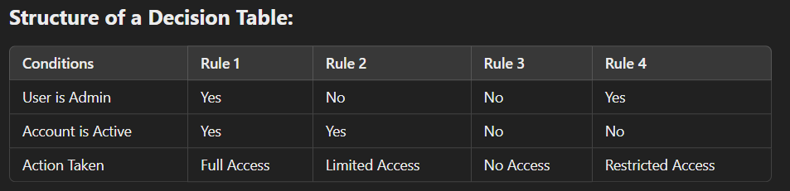

✔ **Example:** A **bank transaction system** can use a decision table to decide whether a user can withdraw money based on conditions like "Sufficient Balance," "Account Type," and "Withdrawal Limit."

**4. Decision Tree**

A **Decision Tree** is a tree-like graphical structure that represents **decision-making logic**. It is an alternative to a decision table but visually intuitive.

**Characteristics:**

✔ **Each internal node** – Represents a condition/question.  
✔ **Each branch** – Represents a decision path.  
✔ **Each leaf node** – Represents an outcome/action.

✔ **Example:** A **loan approval system** can have a decision tree with nodes like:

* **Does the applicant have a stable income?**
  + Yes → Check credit score
  + No → Loan rejected
* **Is credit score above 700?**
  + Yes → Approve loan
  + No → Check collateral availability

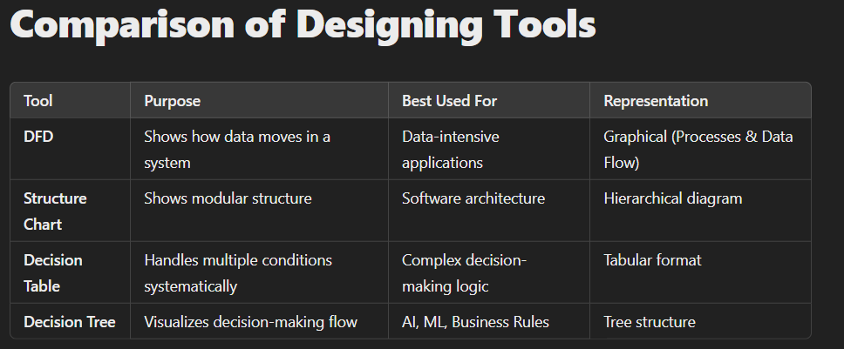

These designing tools help in effective **software planning and documentation**, ensuring clarity and efficiency in the software development process. 🚀

**Designing Approach: Top-Down, Bottom-Up, Hybrid.**

**Software Design Approaches**

Software design approaches define how a system is structured and developed. The three primary approaches are:

1️ **Top-Down Design**  
2️ **Bottom-Up Design**  
3️ **Hybrid Design (Mixed Approach)**

**1. Top-Down Design (Decomposition Approach)**

**Definition:**  
The **Top-Down Approach** begins with the **highest-level system view** and gradually breaks it into smaller, more detailed modules. It follows a **hierarchical decomposition** strategy.

🔹 **Process:**

1. Start with a **general overview** of the system.
2. Divide the system into **major functional modules**.
3. Each module is further divided into **submodules** until they are small enough to be implemented individually.

🔹 **Example:**  
Designing an **e-commerce system** using the top-down approach:

1. Identify the **main components** – User Management, Order Processing, Payment System.
2. Break down **Order Processing** into:
   * Add to Cart
   * Checkout
   * Apply Discount
   * Confirm Payment
3. Further divide **Checkout** into:
   * Address Verification
   * Shipping Method Selection

🔹 **Advantages:**  
✔ Ensures **clear system architecture**  
✔ Helps in **modular development and testing**  
✔ Easy to **understand and maintain**

🔹 **Disadvantages:**  
❌ Requires **complete system knowledge upfront**  
❌ Lower-level details may be **overlooked early on**  
❌ **Dependency between modules** can cause delays

**2. Bottom-Up Design (Composition Approach)**

**Definition:**  
The **Bottom-Up Approach** starts with the development of **independent, low-level components** and gradually integrates them into a complete system. It follows a **building block strategy**.

🔹 **Process:**

1. Identify and build **individual components** (e.g., functions, classes, database tables).
2. Combine small components into **larger subsystems**.
3. Continue integrating until the **full system** is formed.

🔹 **Example:**  
Developing a **banking system** using the bottom-up approach:

1. Start by designing **small, reusable components** like:
   * User authentication module
   * Transaction processing module
   * Interest calculation module
2. Integrate them to form a **Banking Operations System**.
3. Finally, combine them under the **Banking System Interface**.

🔹 **Advantages:**  
✔ Promotes **code reuse** and **efficiency**  
✔ Ideal for **object-oriented programming (OOP)**  
✔ Works well with **existing libraries or frameworks**

🔹 **Disadvantages:**  
❌ Requires **careful integration** to ensure compatibility  
❌ Hard to maintain **overall system structure**  
❌ Can **lack initial clarity** about the complete system

**3. Hybrid Design (Mixed Approach)**

**Definition:**  
The **Hybrid Approach** combines both **top-down** and **bottom-up** methodologies, balancing system-wide architecture with independent component development.

🔹 **Process:**

1. **Top-down**: Define major subsystems and their interactions.
2. **Bottom-up**: Develop critical components independently.
3. **Integrate both approaches** to form the complete system.

🔹 **Example:**  
Developing a **social media application** using the hybrid approach:

1. **Top-down:** Define high-level modules – User Management, Posts, Notifications.
2. **Bottom-up:** Develop independent components like:
   * Profile management
   * Chat system
   * Feed algorithm
3. Integrate all modules and ensure smooth interaction.

🔹 **Advantages:**  
✔ **Balances clarity and flexibility**  
✔ Faster development through **parallel work**  
✔ Allows both **structured planning and modular implementation**

🔹 **Disadvantages:**  
❌ Requires **careful coordination**  
❌ Can lead to **complex dependency management**

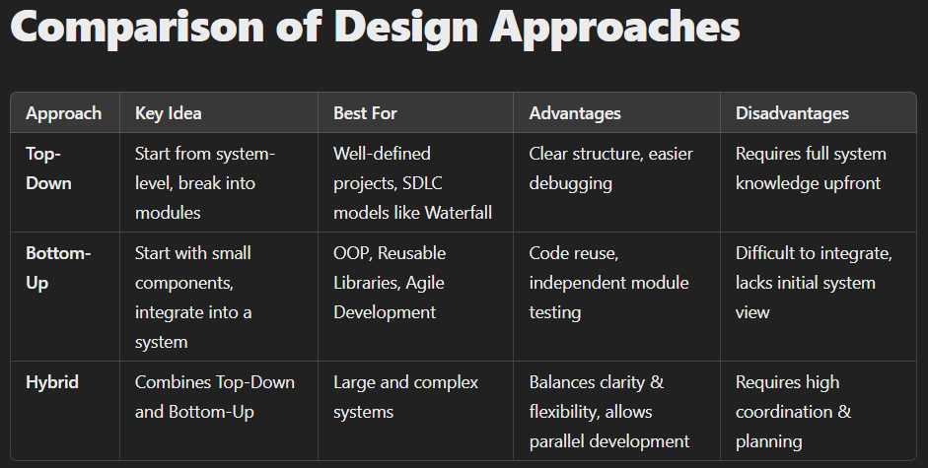

**Conclusion**

* **Top-Down** works best when a **clear system structure** is required from the start.
* **Bottom-Up** is ideal for **component-based development** with existing modules.
* **Hybrid** is the most **practical** and widely used approach in **modern software development**.

**Model: Water Fall, Iterative Waterfall, Prototype, Iterative Enhancement, Spiral, Agile**

**Software Development Models**

Software development models define structured approaches to designing, developing, testing, and maintaining software systems. Different models offer varying degrees of flexibility, risk management, and efficiency. The key models include:

1️ **Waterfall Model**  
2️ **Iterative Waterfall Model**  
3️ **Prototype Model**  
4️ **Iterative Enhancement Model**  
5️ **Spiral Model**  
6️ **Agile Model**

**1. Waterfall Model (Traditional Approach)**

**Overview:**

The **Waterfall Model** is a linear, sequential approach to software development. Each phase **must be completed before moving to the next** without going back.

**Phases:**

📌 **Requirement Analysis** → 📌 **System Design** → 📌 **Implementation** → 📌 **Testing** → 📌 **Deployment** → 📌 **Maintenance**

**Advantages:**

✔ Simple and easy to understand  
✔ Well-structured documentation  
✔ Works well for small, well-defined projects

**Disadvantages:**

❌ No feedback mechanism → High risk of failure  
❌ Cannot handle changing requirements  
❌ Bugs found late in the process are costly to fix

**Best Used For:**

✅ **Projects with fixed requirements** and no expected changes (e.g., government projects, embedded systems).

**2. Iterative Waterfall Model (Improved Waterfall)**

**Overview:**

The **Iterative Waterfall Model** allows feedback and corrections between phases, unlike the rigid Waterfall Model. Each phase is revisited **if issues arise** before proceeding further.

**Key Features:**

🔹 Still follows the **sequential** structure  
🔹 Allows **limited backward movement**  
🔹 Reduces risk compared to traditional Waterfall

**Advantages:**

✔ Allows early error detection  
✔ Better flexibility than Waterfall  
✔ Improves quality through refinement

**Disadvantages:**

❌ Changes still require significant rework  
❌ More costly than pure Waterfall

**Best Used For:**

✅ **Projects where requirements may change slightly but still require structured development.**

**3. Prototype Model (Early Representation Approach)**

**Overview:**

The **Prototype Model** builds an early **working version (prototype)** of the software **before full development**. Users test this prototype and provide feedback, leading to **improvements before actual development** begins.

**Process:**

📌 **Requirement Gathering** → 📌 **Quick Design** → 📌 **Prototype Development** → 📌 **User Feedback** → 📌 **Refinement** → 📌 **Final Development**

**Advantages:**

✔ Reduces risk by validating concepts early  
✔ Allows continuous user involvement  
✔ Leads to **better user satisfaction**

**Disadvantages:**

❌ Requires more development time and effort  
❌ Leads to excessive user demands  
❌ Risk of **scope creep** (uncontrolled feature addition)

**Best Used For:**

✅ **Projects with unclear or evolving requirements** (e.g., new product development, UI-heavy applications).

**4. Iterative Enhancement Model (Progressive Refinement Approach)**

**Overview:**

The **Iterative Enhancement Model** develops the software in **small increments**, with each cycle improving and adding features to the system.

**Process:**

📌 **Initial Development** → 📌 **User Feedback & Refinement** → 📌 **Next Iteration with Enhancements** → 🔁 **Repeat until complete**

**Advantages:**

✔ Faster delivery of core functionalities  
✔ Easier to adapt to changes  
✔ Reduces overall project risk

**Disadvantages:**

❌ Requires **proper planning** for iteration goals  
❌ System architecture must be flexible

**Best Used For:**

✅ **Projects requiring gradual improvements** (e.g., enterprise applications, cloud software).

**5. Spiral Model (Risk-Driven Model)**

**Overview:**

The **Spiral Model** combines **Waterfall and Iterative Development** with a strong focus on **risk management**. The software is developed in loops (spirals), with each iteration refining the product.

**Phases:**

📌 **Planning** → 📌 **Risk Analysis** → 📌 **Development & Testing** → 📌 **Evaluation & Refinement** 🔁 **(Repeat for each spiral)**

**Advantages:**

✔ Best model for **high-risk projects**  
✔ Allows **early risk identification and mitigation**  
✔ Supports **changing requirements**

**Disadvantages:**

❌ Expensive due to continuous risk assessment  
❌ Complex and requires **experienced project management**

**Best Used For:**

✅ **Critical projects where risk is high** (e.g., financial software, defense systems, AI research projects).

**6. Agile Model (Modern, Flexible Approach)**

**Overview:**

The **Agile Model** is an iterative approach that emphasizes **collaboration, flexibility, and rapid delivery** of functional software. Development is done in small cycles (**sprints**), allowing frequent feedback.

**Key Agile Frameworks:**

📌 **Scrum** – Uses sprints, daily stand-up meetings, and iterative development.  
📌 **Kanban** – Uses a visual workflow board to track progress.  
📌 **Extreme Programming (XP)** – Focuses on customer involvement and continuous testing.

**Advantages:**

✔ Highly **flexible and adaptive**  
✔ Delivers working software **faster**  
✔ Continuous user involvement ensures **better product alignment**

**Disadvantages:**

❌ Requires **frequent collaboration**, which can be difficult for distributed teams  
❌ Less emphasis on documentation  
❌ Hard to estimate final cost and timeline

**Best Used For:**

✅ **Dynamic projects where requirements change frequently** (e.g., web development, AI/ML applications, startups).

**Comparison of Software Development Models**

| **Model** | **Approach** | **Flexibility** | **Risk Management** | **Best Use Case** |
| --- | --- | --- | --- | --- |
| **Waterfall** | Sequential | ❌ Low | ❌ Low | Fixed, well-defined projects |
| **Iterative Waterfall** | Sequential with feedback | 🔸 Moderate | 🔸 Moderate | Projects with some flexibility |
| **Prototype** | User-driven early model | ✅ High | 🔸 Moderate | Projects with unclear requirements |
| **Iterative Enhancement** | Incremental improvement | ✅ High | 🔸 Moderate | Gradually evolving projects |
| **Spiral** | Iterative + Risk assessment | ✅ High | ✅ Very High | High-risk, complex projects |
| **Agile** | Iterative, user-focused | ✅ Very High | 🔸 Moderate | Fast-changing environments |

**Conclusion**

* **Waterfall** is best for structured, low-change projects.
* **Iterative Waterfall** allows minor changes while keeping a structured approach.
* **Prototype** is useful when **requirements are unclear**.
* **Iterative Enhancement** provides **continuous improvements**.
* **Spiral** is ideal for **high-risk, large projects**.
* **Agile** is the **best choice for modern, flexible, fast-paced development**.

**Cost Model: Function Point Metric, Estimation Model, Heuristic, COCOMO, Analytical.**

**Software Cost Estimation Models**

Software cost estimation is a critical part of project planning. Various models are used to predict development effort, cost, and resources. The most commonly used cost estimation techniques include:

1️ **Function Point Metric**  
2️ **Estimation Models**  
3️ **Heuristic Models**  
4️ **COCOMO (Constructive Cost Model)**  
5️ **Analytical Models**

**1. Function Point Metric (FPM)**

**Overview:**

Function Point Metric (FPM) is used to estimate **software size** and **complexity** based on user-visible functionalities rather than lines of code (LOC).

**Steps to Calculate Function Points:**

📌 **Identify five key components:**

1. External Inputs (EI)
2. External Outputs (EO)
3. External Inquiries (EQ)
4. Internal Logical Files (ILF)
5. External Interface Files (EIF)

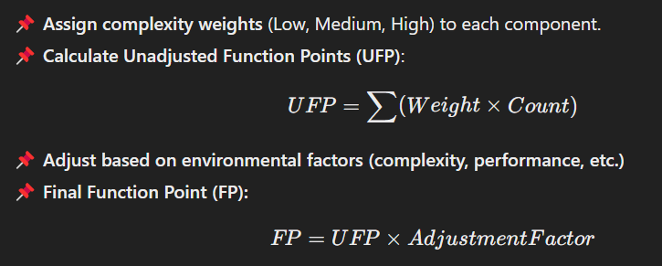

**Advantages:**

✔ Technology-independent → Focuses on user requirements  
✔ Useful for early estimation **before coding begins**  
✔ More accurate than LOC-based estimation

**Disadvantages:**

❌ Requires experience to assign accurate complexity values  
❌ Adjustments can be subjective

**Best Used For:**

✅ **Business applications, database-driven systems, and early-stage estimation.**

**2. Estimation Models**

**Overview:**

Estimation models predict software cost based on past project data, domain experience, and mathematical formulas.

**Common Estimation Techniques:**

📌 **Expert Judgment:** Based on past experience of senior developers.  
📌 **Top-Down Estimation:** Starts from high-level estimation and breaks down into components.  
📌 **Bottom-Up Estimation:** Estimates smaller modules and aggregates them for overall cost.

**Advantages:**

✔ Easy to implement  
✔ Can be combined with other models for better accuracy

**Disadvantages:**

❌ Highly dependent on **human expertise**  
❌ Can be **inaccurate** if past data is missing

**Best Used For:**

✅ **Small projects with well-defined scope.**

**3. Heuristic Models (Rule-Based Estimation)**

**Overview:**

Heuristic models use **rules of thumb**, **empirical formulas**, and **experience-based knowledge** to estimate software cost.

**Examples of Heuristic Methods:**

📌 **80-20 Rule:** 80% of the cost is spent on 20% of the most complex components.  
📌 **Rayleigh Curve Model:** Effort follows a bell-curve (low at the start, peaks at development, decreases after testing).  
📌 **Work Breakdown Structure (WBS):** Divides the project into small manageable parts and estimates costs separately.

**Advantages:**

✔ Simple and easy to use  
✔ Provides quick estimations

**Disadvantages:**

❌ Not accurate for large projects  
❌ **Highly dependent on assumptions**

**Best Used For:**

✅ **Preliminary estimations where detailed data is unavailable.**

**4. COCOMO (Constructive Cost Model)**

**Overview:**

COCOMO is a **mathematical model** that estimates effort and cost based on project size and complexity.

**Types of COCOMO Models:**

🔹 **Basic COCOMO:**

* Suitable for **small projects**

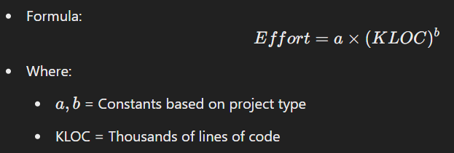

🔹 **Intermediate COCOMO:**

* Considers additional **cost drivers** like team experience, tools, and software constraints.

🔹 **Detailed COCOMO:**

* Further refines estimates by dividing software into **subsystems** and evaluating cost for each.

**COCOMO Project Categories:**

📌 **Organic:** Small teams, well-understood projects (e.g., payroll system).  
📌 **Semi-Detached:** Medium complexity, mix of experience levels (e.g., banking software).  
📌 **Embedded:** Highly complex, real-time constraints (e.g., aerospace software).

**Advantages:**

✔ Well-defined mathematical basis  
✔ Works for **different types of projects**  
✔ Can be fine-tuned with real-world data

**Disadvantages:**

❌ Requires detailed project information  
❌ Not suitable for **modern Agile projects**

**Best Used For:**

✅ **Large software projects with well-defined requirements.**

**5. Analytical Models**

**Overview:**

Analytical models use **statistical and mathematical approaches** to predict software cost. These models require **historical project data** and apply regression, machine learning, or probabilistic methods.

**Examples:**

📌 **Putnam Model (SLIM):** Uses **effort distribution over time** to estimate cost.  
📌 **Bayesian Networks:** Uses probability distributions for **uncertain estimates**.  
📌 **Regression Models:** Use past project data to predict cost trends.

**Advantages:**

✔ Can be **highly accurate** with good data  
✔ Suitable for **large-scale, complex systems**

**Disadvantages:**

❌ Requires **large historical datasets**  
❌ Difficult to implement without **statistical expertise**

**Best Used For:**

✅ **Big enterprise projects, AI-driven estimation tools.**

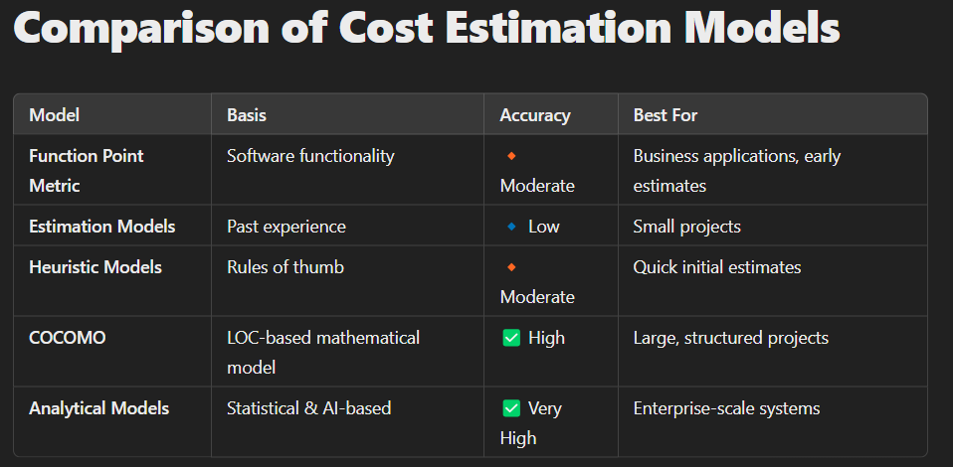

**Conclusion**

* **Function Point Metric** is useful for early estimates based on user requirements.
* **Estimation Models** are **simple and quick** but **less accurate**.
* **Heuristic Methods** provide **fast estimations** but **lack precision**.
* **COCOMO** is **widely used for large software development** efforts.
* **Analytical Models** offer **the highest accuracy** but require **data and expertise**.

**Testing: Program Testing: Unit Testing, Integration Testing**

**System Testing: Function Testing, Performance Testing, Acceptance Testing.**

**Software Testing**

**Introduction to Software Testing**

Software testing is the process of verifying and validating that a software system meets the specified requirements and is free of defects. The goal is to identify errors and ensure the software functions correctly under all conditions.

**Types of Software Testing:**

1️ **Program Testing:** Focuses on individual components and their integration.

* **Unit Testing**
* **Integration Testing**

2️ **System Testing:** Evaluates the complete system.

* **Functional Testing**
* **Performance Testing**
* **Acceptance Testing**

**1. Program Testing**

Program testing involves testing **individual modules and their interactions** before the full system is evaluated.

**📌 Unit Testing**

🔹 Tests **individual components** (functions, classes, modules) in isolation.  
🔹 Performed by **developers** using test frameworks like JUnit (Java), PyTest (Python), or NUnit (C#).

**Key Features:**

✅ Detects early bugs in a controlled environment.  
✅ Uses automated tests for efficiency.  
✅ Ensures each module works before integration.

**Example:**

Testing a **login function** separately before integrating it with the authentication system.

**📌 Integration Testing**

🔹 Tests **how multiple components interact**.  
🔹 Ensures correct **data flow** between modules.  
🔹 Performed **after unit testing** but before system testing.

**Types of Integration Testing:**

🔸 **Top-Down Approach:** Starts with high-level modules, then integrates lower ones.  
🔸 **Bottom-Up Approach:** Tests lower-level modules first, then integrates with higher ones.  
🔸 **Big Bang Approach:** All components are combined and tested together.  
🔸 **Incremental Approach:** Modules are tested step by step in phases.

**Key Features:**

✅ Detects **interface mismatches** and **data flow issues**.  
✅ Ensures modules work **together as expected**.

**Example:**

Testing how the **payment module** integrates with the **order processing module** in an e-commerce website.

**2. System Testing**

System testing evaluates the **entire software system** as a whole to ensure it meets business requirements.

**📌 Functional Testing**

🔹 Verifies that the system **performs as per the requirements**.  
🔹 Focuses on **user inputs, outputs, and expected behavior**.  
🔹 Conducted using **manual testing or automation tools** like Selenium, TestNG, or Postman.

**Key Features:**

✅ Ensures all functionalities work as expected.  
✅ Tests **UI, APIs, databases, and security**.

**Example:**

Checking if a **search function** returns the correct results in an online store.

**📌 Performance Testing**

🔹 Evaluates system **speed, scalability, and stability** under load.  
🔹 Ensures the software meets **performance benchmarks**.

**Types of Performance Testing:**

🔸 **Load Testing:** Tests system behavior under expected user load.  
🔸 **Stress Testing:** Pushes the system beyond limits to check failure points.  
🔸 **Scalability Testing:** Tests the system’s ability to **handle growth**.  
🔸 **Endurance Testing:** Checks stability under **prolonged usage**.

**Key Features:**

✅ Ensures the system does not **crash under high usage**.  
✅ Identifies **bottlenecks** in CPU, memory, or database queries.

**Example:**

Testing how a **ticket booking website** performs when 100,000 users access it simultaneously.

**📌 Acceptance Testing**

🔹 Ensures the software meets **business and user requirements** before deployment.  
🔹 Conducted by **end users or clients** before final approval.

**Types of Acceptance Testing:**

🔸 **User Acceptance Testing (UAT):** End-users verify that the system meets expectations.  
🔸 **Alpha Testing:** Conducted in a **controlled internal environment** by developers.  
🔸 **Beta Testing:** Performed by **real users in a real environment** before release.

**Key Features:**

✅ Ensures **customer satisfaction** before deployment.  
✅ Identifies **last-minute usability or requirement issues**.

**Example:**

A **banking application** undergoing UAT with real employees before going live.

**Comparison of Testing Techniques**

| **Testing Type** | **Purpose** | **Who Performs?** | **Scope** |
| --- | --- | --- | --- |
| **Unit Testing** | Tests **individual modules** | Developers | Smallest scope (single function/class) |
| **Integration Testing** | Tests **module interactions** | Developers/Testers | Medium scope (multiple modules) |
| **Functional Testing** | Verifies expected **system behavior** | QA/Testers | Full system |
| **Performance Testing** | Tests **speed & scalability** | Performance Testers | Full system under load |
| **Acceptance Testing** | Ensures system meets **business needs** | End users/Clients | Entire application |

**Conclusion**

* **Unit Testing** ensures individual components work correctly.
* **Integration Testing** verifies module interactions.
* **Functional Testing** ensures the system meets functional requirements.
* **Performance Testing** tests **scalability & speed**.
* **Acceptance Testing** validates **business & user requirements** before release.

**Maintenance: Objective, Cost, Types: Corrective, Preventive, Perfective, Adaptive.**

**Software Maintenance**

**Introduction**

Software maintenance is the process of modifying a software system after it has been deployed. The goal is to ensure the software remains functional, efficient, and aligned with user needs over time. Maintenance accounts for **60-80% of the total software cost**, making it a **critical phase in the Software Development Life Cycle (SDLC)**.

**Objectives of Software Maintenance**

1️ **Error Correction:** Fix defects discovered after deployment.  
2️ **Performance Improvement:** Optimize efficiency and speed.  
3️ **Adaptation to Environment:** Modify software for new hardware, OS, or regulations.  
4️ **Enhancing Functionality:** Improve or add new features as per user needs.  
5️ **Extending Software Life:** Ensure the software remains usable for a long time.

**Cost of Software Maintenance**

Software maintenance is expensive due to:  
📌 **Complexity of Code:** Older software may have **poor documentation or obsolete technology**.  
📌 **Frequent Updates:** Regular **feature additions and security patches**.  
📌 **User Expectations:** Constant demand for **new features** and **improved performance**.  
📌 **Testing and Verification:** Ensuring the updates do not introduce **new errors**.  
📌 **Developer Turnover:** New developers take time to **understand old codebases**.

**Cost Breakdown:**

* **Understanding existing code** → 40-50%
* **Implementing changes** → 20-30%
* **Testing and deployment** → 20-30%

**Types of Software Maintenance**

Software maintenance is categorized into **four types:**

**1️ Corrective Maintenance (Bug Fixing) 🛠️**

🔹 Fixes **bugs, errors, and defects** found in the software.  
🔹 Can be due to **user-reported issues** or **internal testing**.  
🔹 Includes **fixing crashes, logical errors, and security vulnerabilities**.

✅ **Example:** Fixing a **login failure issue** in a banking application.

**2️ Preventive Maintenance (Proactive Improvement) 🔄**

🔹 **Prevents future failures** by improving code quality and structure.  
🔹 Identifies **potential risks** and eliminates them **before they cause issues**.  
🔹 Includes **code refactoring, documentation updates, and security enhancements**.

✅ **Example:** Rewriting inefficient **database queries** to improve response time before users report slow performance.

**3️ Perfective Maintenance (Feature Enhancement) 🚀**

🔹 Adds **new features or improves existing functionalities** based on user feedback.  
🔹 Ensures the software remains **relevant and competitive** in the market.  
🔹 Focuses on **UI/UX improvements, additional functionalities, and workflow enhancements**.

✅ **Example:** Adding **dark mode support** in a mobile application based on user demand.

**4️ Adaptive Maintenance (Environmental Changes) 🌍**

🔹 Modifies software to **adapt to external changes**, such as:

* New **hardware** (e.g., migrating software to new servers).
* New **operating systems** (e.g., updating an app for Windows 11).
* Regulatory **compliance** (e.g., updating software for GDPR compliance).  
  🔹 Ensures **compatibility** with the latest technologies and environments.

✅ **Example:** Updating an **e-commerce app** to support **new payment methods like UPI**.

**Comparison of Maintenance Types**

| **Type** | **Purpose** | **When Needed?** | **Example** |
| --- | --- | --- | --- |
| **Corrective** | Fixes **bugs & errors** | When issues arise | Fixing login failures |
| **Preventive** | Reduces **future failures** | Proactive updates | Optimizing slow code |
| **Perfective** | Enhances **features** | User demand | Adding dark mode |
| **Adaptive** | Adapts to **new environments** | External changes | Supporting new OS |

**Conclusion**

* **Corrective Maintenance** fixes existing **bugs**.
* **Preventive Maintenance** avoids **future issues**.
* **Perfective Maintenance** enhances **features & usability**.
* **Adaptive Maintenance** ensures **compatibility with changing environments**.

**Quality: Metrics, SQA activities, Standard, Verification, Validation, Review, Inspection,**

**Walkthrough.**

**Software Quality Assurance (SQA)**

**Introduction to Software Quality**

Software quality refers to the degree to which software meets **customer expectations, functional requirements, and industry standards**. It ensures that software is **reliable, maintainable, and efficient** while minimizing defects.

**Software Quality Assurance (SQA)** is a set of activities designed to **ensure quality throughout the Software Development Life Cycle (SDLC)**. It involves **defining standards, monitoring development, and conducting reviews and testing**.

**1️ Software Quality Metrics**

Metrics are used to measure software quality quantitatively. They help in evaluating **performance, reliability, maintainability, and defect rates**.

**📌 Key Software Quality Metrics:**

| **Metric** | **Definition** | **Formula / Measurement** |
| --- | --- | --- |
| **Defect Density** | Measures the number of defects per unit of code. | (Defects found / KLOC) → Defects per 1000 lines of code (KLOC) |
| **Mean Time to Failure (MTTF)** | Measures the **average time before a system fails**. | Total operational time / Number of failures |
| **Mean Time to Repair (MTTR)** | Measures the **average time to fix a failure**. | Total repair time / Number of failures |
| **Reliability** | Measures system stability over time. | MTTF / (MTTF + MTTR) |
| **Test Coverage** | Percentage of the system covered by tests. | (Tested code lines / Total code lines) × 100 |
| **Customer Satisfaction** | Measures user satisfaction through surveys and ratings. | Average user rating from feedback forms |

**2️ Software Quality Assurance (SQA) Activities**

SQA ensures that **quality is built into the process, rather than tested at the end**.

**🔹 Key SQA Activities:**

✅ **Defining Quality Standards:** Establishing coding guidelines, testing processes, and documentation practices.  
✅ **Process Monitoring:** Ensuring SDLC phases follow best practices and standards.  
✅ **Audits & Reviews:** Conducting inspections, walkthroughs, and technical reviews.  
✅ **Defect Tracking:** Identifying, documenting, and resolving defects.  
✅ **Risk Management:** Predicting and mitigating **potential software failures**.  
✅ **Process Improvement:** Using methodologies like **Six Sigma, CMMI, and ISO 9001**.

**3️ Software Quality Standards**

Standards help maintain **consistent and high-quality software development practices**.

**📌 Important Standards:**

| **Standard** | **Description** |
| --- | --- |
| **ISO 9001** | Focuses on general **quality management principles**. |
| **ISO/IEC 9126** | Defines software quality attributes like reliability, maintainability, usability. |
| **CMMI (Capability Maturity Model Integration)** | Provides a framework for **process improvement** in software development. |
| **IEEE 829** | Defines **test documentation standards**. |
| **Six Sigma** | Focuses on **defect reduction and process improvement**. |

**4️ Verification and Validation**

📌 **Verification:** "Are we building the product **right**?"  
📌 **Validation:** "Are we building the **right** product?"

| **Aspect** | **Verification** | **Validation** |
| --- | --- | --- |
| **Purpose** | Ensures software is developed **correctly**. | Ensures software meets **user needs**. |
| **Focus** | **Process-oriented** (checking design, requirements). | **Product-oriented** (checking final system). |
| **Performed During** | Development phase (before testing). | Testing phase (before release). |
| **Methods** | Reviews, walkthroughs, inspections. | Functional testing, UAT, beta testing. |
| **Example** | Checking whether **design documents** match requirements. | Checking if software meets **customer expectations**. |

**5️ Software Reviews**

Reviews are **systematic evaluations of software artifacts** to detect defects early.

**📌 Types of Reviews:**

| **Type** | **Purpose** | **Performed by** |
| --- | --- | --- |
| **Technical Review** | Ensures **technical accuracy** of software components. | Developers & Architects |
| **Code Review** | Finds coding errors and enforces best practices. | Developers & Peers |
| **Management Review** | Evaluates software project **progress and risks**. | Project Managers |
| **Requirement Review** | Ensures **requirements are clear and complete**. | Business Analysts & Stakeholders |

**6️ Inspection and Walkthrough**

**🔹 Inspection (Formal Review) 📑**

* **Highly structured** review process.
* Conducted by **experienced professionals**.
* Detects **errors, compliance issues, and inconsistencies**.

✅ **Example:** Reviewing software design **before implementation** to check for **potential flaws**.

**🔹 Walkthrough (Informal Review) 👥**

* **Less formal** than inspections.
* Conducted by **developers and peers** to improve understanding.
* No formal defect tracking, but provides **early feedback**.

✅ **Example:** A **junior developer** presents code to **senior engineers** for improvement suggestions.

**Conclusion**

* **Quality Metrics** track software reliability and performance.
* **SQA Activities** ensure quality throughout the SDLC.
* **Industry Standards** (ISO, CMMI) guide best practices.
* **Verification & Validation** ensure correctness and user satisfaction.
* **Reviews, Inspections, Walkthroughs** detect defects early.

**Risk Analysis: Identification, Projection, Refinement, Monitoring & Management.**

**Risk Analysis in Software Engineering**

**Introduction**

Risk analysis is the process of **identifying, assessing, and managing potential risks** that could impact the success of a software project. Risks can lead to **budget overruns, delays, security vulnerabilities, or project failures**. Effective risk management helps in **reducing uncertainties and ensuring smooth project execution**.

**1️ Risk Identification**

📌 **Goal:** Recognize potential risks that could affect the software project.  
📌 **Sources of Risks:**  
🔹 **Project Risks** – Budget overruns, scope creep, resource constraints.  
🔹 **Technical Risks** – Incompatibility, scalability, performance issues.  
🔹 **Business Risks** – Changing requirements, stakeholder conflicts.  
🔹 **Security Risks** – Data breaches, compliance violations.  
🔹 **Operational Risks** – Deployment failures, system downtime.

✅ **Example:** A company developing an AI-powered chatbot may face risks like **inaccurate responses due to poor training data**.

**2️ Risk Projection (Risk Assessment)**

📌 **Goal:** Estimate the probability and impact of each identified risk.

**Risk Assessment Techniques:**  
🔹 **Qualitative Analysis** – Uses a **risk matrix** to classify risks as **low, medium, or high**.  
🔹 **Quantitative Analysis** – Uses numerical methods like **Monte Carlo simulations** to estimate risk impact.

**📌 Risk Matrix Example:**

| **Risk** | **Probability** | **Impact** | **Risk Level** |
| --- | --- | --- | --- |
| Security Breach | High | Critical | Severe |
| Scope Creep | Medium | High | Major |
| Performance Issues | Low | Medium | Moderate |

✅ **Example:** A **high probability, high impact** risk, like a **security breach**, must be addressed immediately.

**3️ Risk Refinement (Prioritization & Analysis)**

📌 **Goal:** Break down high-priority risks for deeper analysis and mitigation planning.

**🔹 Steps in Risk Refinement:**

✅ **Categorize Risks:**

* **Essential Risks:** Must be addressed immediately (e.g., security issues).
* **Desirable Risks:** Should be handled if resources allow (e.g., UI improvements).

✅ **Break Down Risks Further:**

* Example: If "performance issues" are a risk, refine it into **slow response time, high memory consumption, or server overload**.

✅ **Create Mitigation Plans:**

* **Avoid**: Change project strategy to eliminate risk.
* **Mitigate**: Reduce the probability or impact of the risk.
* **Accept**: If unavoidable, plan for damage control.

✅ **Example:** If a system is **prone to memory leaks**, developers may refine the risk by analyzing **which modules cause the issue** and implement **automated memory profiling tools**.

**4️ Risk Monitoring**

📌 **Goal:** Continuously track and update risk status throughout the project lifecycle.

**🔹 Risk Monitoring Activities:**  
✅ **Track Identified Risks** – Maintain a **risk register** with status updates.  
✅ **Monitor New Risks** – Identify new risks as the project evolves.  
✅ **Use Risk Metrics** – Example: **Defect Density** to monitor quality risks.  
✅ **Regular Risk Reviews** – Weekly or monthly meetings to reassess risk levels.

✅ **Example:** If a **key developer resigns**, the risk must be **tracked and updated**, ensuring that a replacement is hired **before delays occur**.

**5️ Risk Management (Risk Mitigation Strategies)**

📌 **Goal:** Implement strategies to handle risks effectively.

**📌 Risk Mitigation Strategies:**

| **Strategy** | **Description** | **Example** |
| --- | --- | --- |
| **Risk Avoidance** | Modify the project plan to eliminate the risk. | Use **pre-tested components** to avoid bugs. |
| **Risk Reduction** | Take actions to **minimize risk impact**. | Conduct **code reviews** to prevent security vulnerabilities. |
| **Risk Transfer** | Shift the risk to a third party. | Use **cloud services** to handle scalability instead of managing servers. |
| **Risk Acceptance** | Accept the risk and prepare for potential consequences. | Acknowledge that **AI models may have biases** and work on reducing them over time. |

✅ **Example:** If **server downtime** is a risk, mitigation strategies may include:  
✔ **Avoidance**: Choosing a **high-availability cloud provider**.  
✔ **Reduction**: Implementing **automatic failover** and **load balancing**.  
✔ **Transfer**: Using **third-party hosting services**.  
✔ **Acceptance**: Preparing a **manual recovery plan**.

**Conclusion**

* **Risk Identification:** Recognize potential risks.
* **Risk Projection:** Assess probability and impact.
* **Risk Refinement:** Prioritize and analyze risks in detail.
* **Risk Monitoring:** Track risks continuously.
* **Risk Management:** Apply mitigation strategies.

**Management Activities: Software Project Management, Software Configuration Management,**

**Staffing, Scheduling.**

**Software Management Activities**

Software management activities ensure the **successful planning, execution, and delivery** of software projects. These activities cover project management, configuration management, staffing, and scheduling.

**1️ Software Project Management (SPM)**

📌 **Goal:** Efficiently **plan, execute, monitor, and control** software projects to meet quality, cost, and time constraints.

**🔹 Key Responsibilities of SPM:**

✅ **Project Planning:** Define scope, resources, timeline, and budget.  
✅ **Risk Management:** Identify and mitigate risks (e.g., delays, cost overruns).  
✅ **Quality Management:** Ensure software meets required standards.  
✅ **Communication Management:** Maintain effective communication between stakeholders.  
✅ **Change Management:** Handle requirement changes efficiently.

✅ **Example:** Managing the development of a **banking application** involves coordinating teams, ensuring security compliance, and keeping development **within budget and deadline**.

**2️ Software Configuration Management (SCM)**

📌 **Goal:** **Track and control changes** in software development to ensure consistency and prevent errors.

**🔹 Key Activities in SCM:**

🔹 **Version Control** – Manage different versions of software (e.g., Git, SVN).  
🔹 **Change Management** – Track and approve modifications to requirements, code, and design.  
🔹 **Build Management** – Automate software compilation, testing, and deployment.  
🔹 **Release Management** – Handle software updates and rollbacks efficiently.

✅ **Example:** A development team using **GitHub** for version control ensures that changes are properly tracked, preventing conflicts and ensuring smooth collaboration.

**3️ Software Staffing**

📌 **Goal:** Assign the **right people to the right tasks** based on their skills and experience.

**🔹 Key Aspects of Staffing:**

✅ **Identifying Roles:** Define required positions (e.g., Developers, Testers, UI/UX Designers).  
✅ **Hiring & Training:** Recruit skilled employees and provide training on **new technologies**.  
✅ **Resource Allocation:** Assign **tasks based on expertise** to maximize efficiency.  
✅ **Team Development:** Encourage collaboration and problem-solving skills.

✅ **Example:** In a **large-scale AI project**, a team might include:  
✔ **ML Engineers** for model development.  
✔ **Data Scientists** for data preprocessing.  
✔ **Software Engineers** for backend integration.  
✔ **QA Testers** for performance testing.

**4️ Software Scheduling**

📌 **Goal:** Plan project activities to ensure **timely completion** while optimizing resources.

**🔹 Key Scheduling Techniques:**

| **Technique** | **Description** | **Example** |
| --- | --- | --- |
| **Gantt Chart** | Visual timeline of tasks and deadlines. | Track the progress of coding, testing, and deployment. |
| **PERT (Program Evaluation and Review Technique)** | Identifies the shortest and longest project duration. | Used for risk analysis in complex projects. |
| **Critical Path Method (CPM)** | Identifies essential tasks that **must** be completed on time. | Determines which activities directly impact project delivery. |
| **Time Boxing** | Assigns fixed time slots for each phase. | Agile teams use **sprints** of 2-4 weeks. |

✅ **Example:** A **Gantt Chart for a mobile app project** might allocate:  
✔ **2 weeks** for UI/UX design.  
✔ **4 weeks** for backend development.  
✔ **2 weeks** for testing.  
✔ **1 week** for deployment.

**Conclusion**

* **Software Project Management (SPM):** Ensures smooth execution and delivery.
* **Software Configuration Management (SCM):** Tracks and manages software changes.
* **Staffing:** Assigns the right personnel to each task.
* **Scheduling:** Ensures **on-time** project completion using planning techniques.

**Advanced Methodologies: Reverse Engineering, Re-Engineering, UML**

**Advanced Software Engineering Methodologies**

Modern software engineering methodologies enhance **efficiency, maintainability, and scalability**. This section covers **Reverse Engineering, Re-Engineering, and UML (Unified Modeling Language).**

**1️ Reverse Engineering**

📌 **Definition:**  
Reverse engineering is the process of **analyzing and understanding existing software** to extract **design, architecture, and functionality** without prior knowledge of its development.

📌 **Goal:**

* Recover **lost documentation**.
* Identify **security vulnerabilities**.
* Migrate **legacy systems** to new platforms.
* Understand **competitor’s software** (for ethical hacking).

**🔹 Stages of Reverse Engineering:**

| **Stage** | **Description** |
| --- | --- |
| **Collection** | Gather source code, binaries, and documentation. |
| **Analysis** | Examine code structure, dependencies, and functionality. |
| **Abstraction** | Create high-level representations (UML diagrams, flowcharts). |
| **Re-documentation** | Generate new documentation for maintainability. |

✅ **Example:** An IT firm **reverse engineers** a Windows application to find vulnerabilities and enhance security.

**2️ Re-Engineering**

📌 **Definition:**  
Re-engineering is the **modification and improvement** of an existing software system **without changing its core functionality**.

📌 **Goal:**

* Improve **performance and scalability**.
* Enhance **readability and maintainability**.
* Transition **old applications** to **modern technologies**.
* **Reduce technical debt** by refactoring code.

**🔹 Process of Re-Engineering:**

| **Stage** | **Description** |
| --- | --- |
| **Reverse Engineering** | Analyze existing code and document it. |
| **Restructuring** | Modify and refactor inefficient code. |
| **Forward Engineering** | Develop a new system with enhanced architecture. |
| **Testing & Deployment** | Ensure the re-engineered system works correctly. |

✅ **Example:** Migrating a **COBOL-based banking system** to **Java Spring Boot** while maintaining core banking logic.

**3️ Unified Modeling Language (UML)**

📌 **Definition:**  
UML is a standardized **visual modeling language** for software design. It helps developers **visualize, specify, and document** software architecture.

📌 **Goal:**

* Standardize **system design and communication**.
* Improve **software documentation**.
* Enable **better collaboration** between developers and stakeholders.

**🔹 Types of UML Diagrams:**

✅ **Structural Diagrams (Define system components & relationships)**

1. **Class Diagram** – Shows **objects, attributes, methods, and relationships**.
2. **Object Diagram** – Represents **specific instances** of classes.
3. **Component Diagram** – Represents **modules and dependencies**.
4. **Deployment Diagram** – Shows **hardware and software configurations**.

✅ **Behavioral Diagrams (Describe system behavior & interactions)**

1. **Use Case Diagram** – Shows **interactions between users and the system**.
2. **Sequence Diagram** – Depicts **message flow** in time order.
3. **Activity Diagram** – Represents **workflow** and processes.
4. **State Diagram** – Represents **different states of an object**.

**Conclusion**

* **Reverse Engineering:** Extracts system information for documentation and security.
* **Re-Engineering:** Improves outdated software **without losing functionality**.
* **UML:** Standardizes software design through **visual diagrams**.